**STEP01: DSIPLAY Below screen for taking input.**

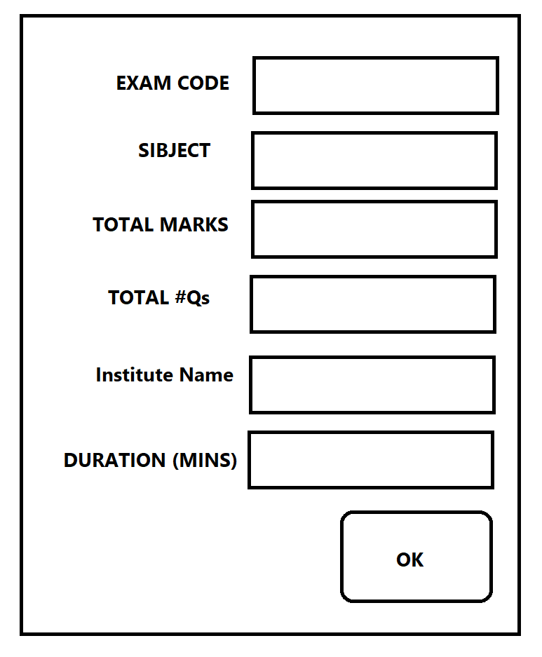

**STEP2: Display all the input information in next screen at its specific places.**

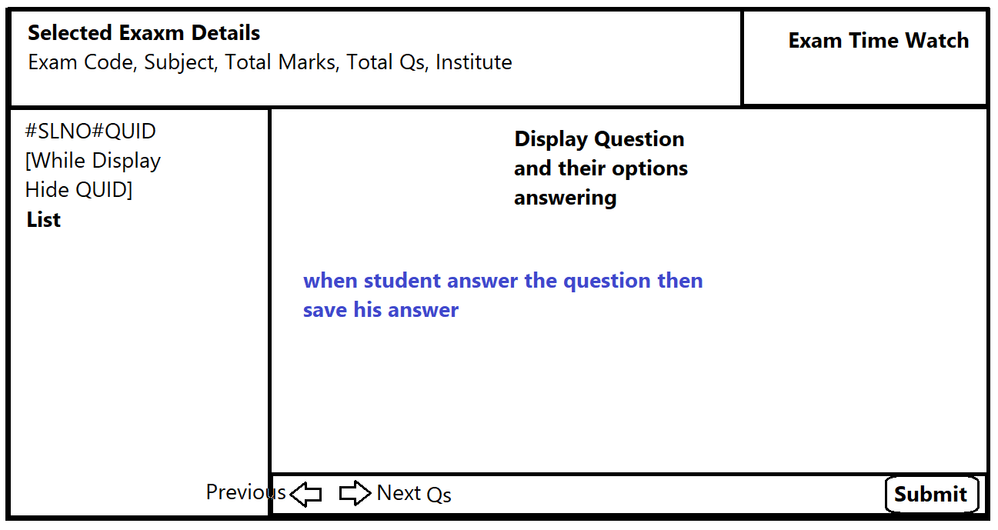

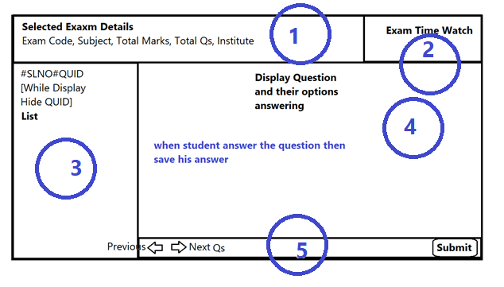

**Information displayed in section1**

All the information which is collected from first screen.

**Information displayed in section2**

Display a watch ticker = exam duration – spent time;

This means it will always show the remaining time

**Information displayed in section3**

#SLNO#QSNO_IN_RANDOM_ORDER

Example

#1#Question5

#2#Question2

#3#Question1

#4#Question4

#5#Question3



**QID|QUESTION**

QUESTION1|Who was the writer of RAMAYAN?

QUESTION2|Who was the writer of RAMCHARITMANAS?

QUESTION3|How Many AVTAR of GOD VISHNU?

QUESTION4|how many chapters are there in gita?

QUESTION5|Bhagwan RAM ne Mata SABRI JI ko KITNI BHAKTI ka gyan diya tha?

QUESTION6|what will be the answer of (a+b)*(a+b)?

QUESTION7|Who was the director of TV Serial Chankya?

QUESTION8|What are all the states of India which was ealier comes in Vijay Nagaram?

QUESTION9|Tenaliram was belongs to which Kingdome?

QUESTION10|Who was the writer of Mudraraksha?

QUESTION11|what was the distance of Lanka from Rameswaram?

These data must be inserted in SQLite DB and read from the same.

The red part will be hidden one.

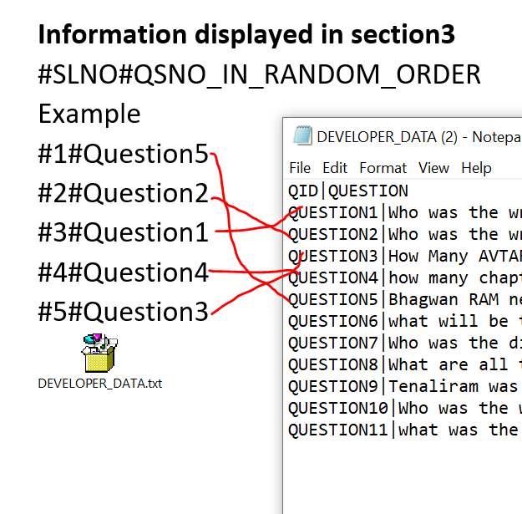

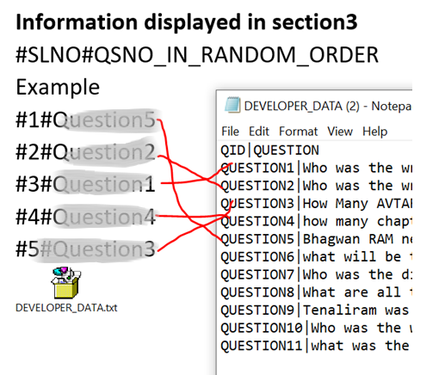

**When you click on the particular #SLNO#QS then the description of Qs will be displayed in section4.**

**Next & Previous Button**

**When you hit next button then next question will be highlighted from its current pointer.**

**When you hit previous button then previous question will be highlighted from its current pointer.**

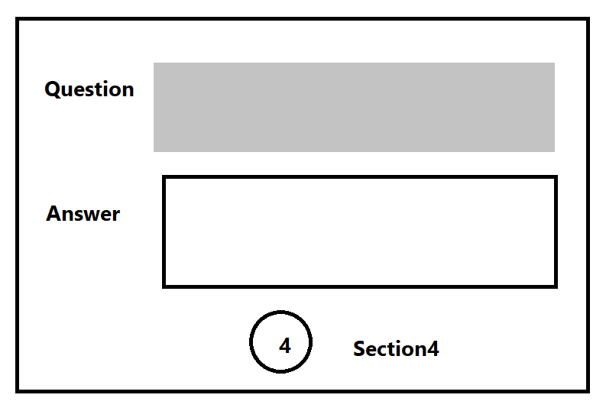

**When you change your answer then alert a MESSAGE “Answer is changed”**

**SUBMIT BUTTON**

**Button will be hit in two ways: -**

1. **When you manually hit it.**
2. **When remaining time=0**

**Display message that “your answer is submitted”**